Section 4(i) |  | Corporate Profile
Section 4(i)(b) |  | Detailed information of not more than 5 job references for each discipline of similar size as the Accommodation
3.0 | Building Services Engineer

Project: | "LST Housing"「樂屋」  Conversation of Ex-Tsuen Wan Lutheran School for  Transitional Housing at Cheung Shan Est., Tsuen Wan, HK
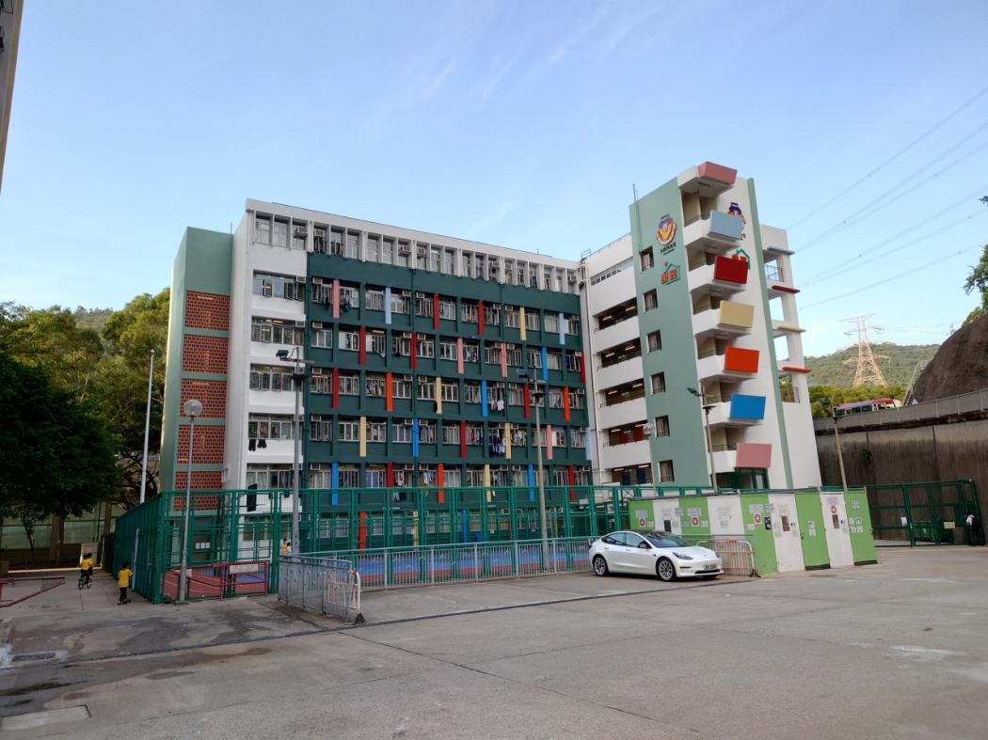

Project Description
The transitional housing of 145 flat units is converted from an existing vacant primary school building with site area of 1450m2 located in Cheung Shan Estate, Tsuen Wan. This project aims to provide affordable rental housing for low-income families. Talent carried out M&E design and project administration for the project. The transitional houses were completed and officially put into service in the first quarter of 2022. This marks the vicissitudes of the city from baby booming era to the aging of the society.

Project Type: | Residential
Project Cost: | HK$46M
Completion: | Jun., 2021 - Feb., 2023
Client: | Lok Sin Tong

Project: | 8-12 Peak Road  Renovation for Residential Development at I.L. 7878,  8-12 Peak Road, Hong Kong
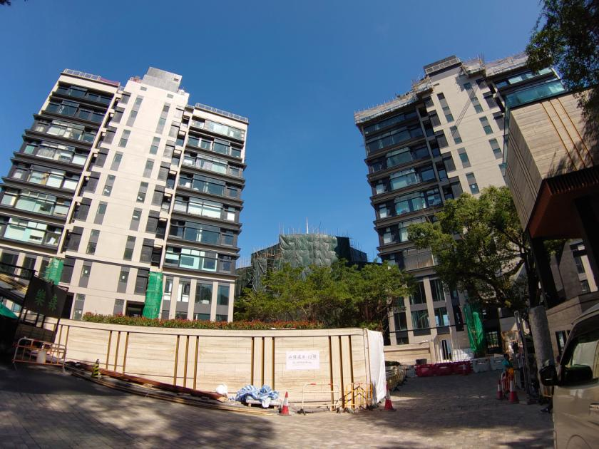

Project Description
The existing premises comprise 2 blocks of 11-storey deluxe residential towers, 1 block of private house together with basement carpark and clubhouse with total domestic gloss floor area of around 8,500m². Major renovations include two parts, common area and apartment area. The major scope of work includes M&E associated modification for re-partitioning, complete replacement and upgrading of existing M&E services and security system.

Project Type: | Residential
Project Cost: | HK$18M
Completion: | Nov., 2016 - Dec., 2022
Client: | Couture Homes Ltd.

Project: | Victoria Skye (天寰)  Proposed Residential Development at NKIL 6525, Kai Tak, Hong Kong
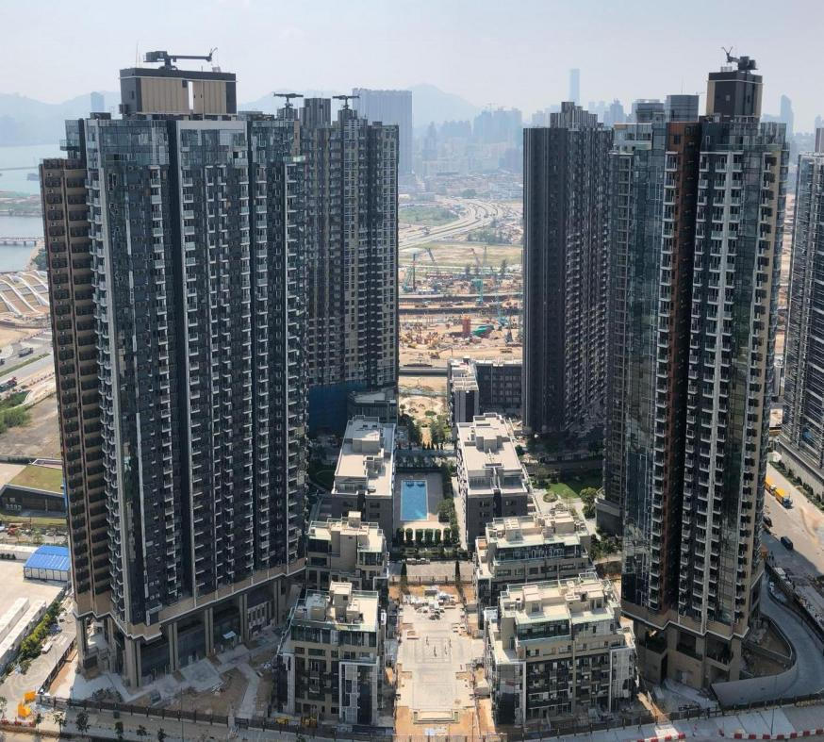
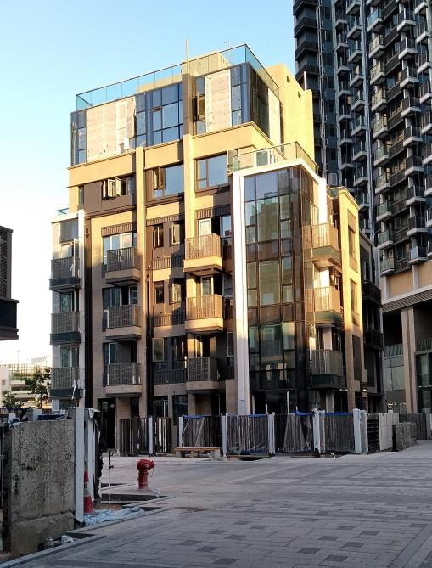

Project Description
The development comprises 2 high rise and 4 low rise residential towers with total floor area of around 48,000m² and 822 flats including residents' club houses, swimming pool, basement carpark and landscape garden. The project was designed and constructed under the BEAM Plus "Unclassified" rating.

Project Type: | Residential
Project Cost: | HK$370M
Completion: | Jul., 2014 - Nov., 2019
Client: | K&K Property Holdings Ltd.

Project: | Dragons Range (玖瓏山)  Residential Development at STTL 525, Kau To Shan, Shatin, Hong Kong
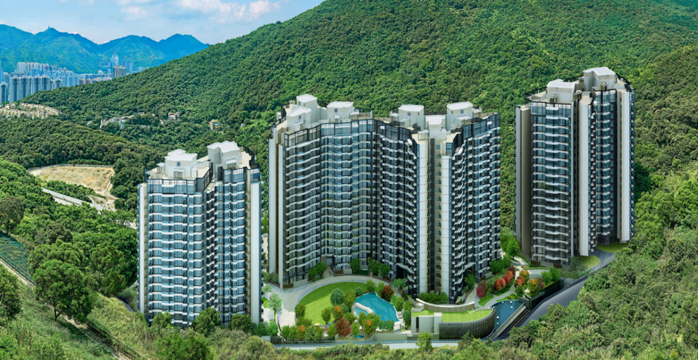

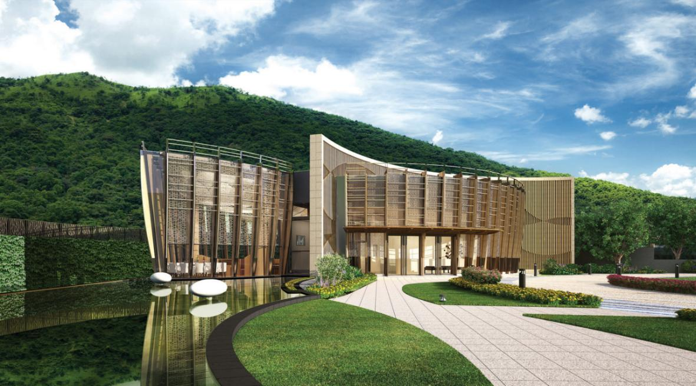

Project Description
The development comprises of ten residential blocks together with clubhouse, carparks and landscape garden with total floor area of 96,000m² approximately and 973 flats. This project is with complex slope condition / site formation. Talent carried out M&E design and project administration.

Project Type: | Residential
Project Cost: | HK$460M
Completion: | Oct., 2011 - Oct., 2015
Client: | Kerry Project Management (HK) Ltd.

Project: | Mayfair by the Sea I & II (逸瓏灣 I & II )  Residential Development at TPTL 200 & 201, Pak Shek Kok, Tai Po, Hong Kong
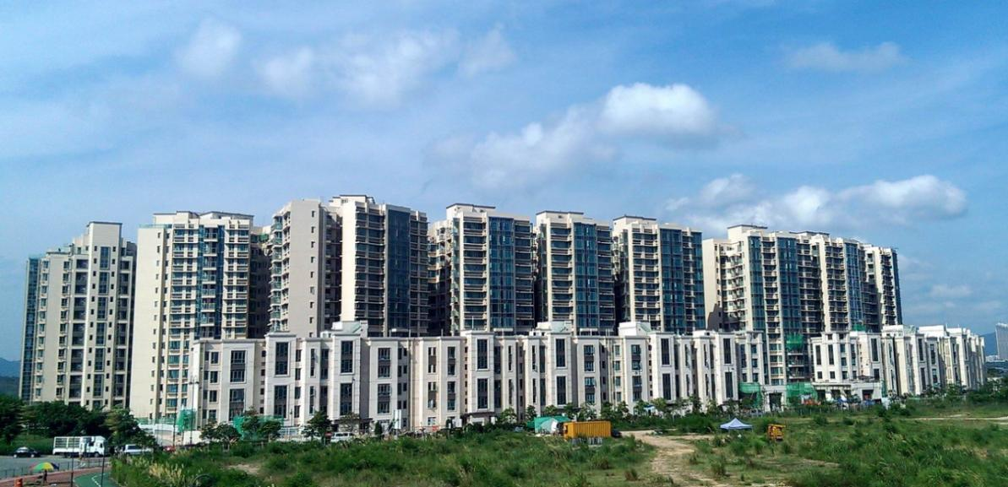

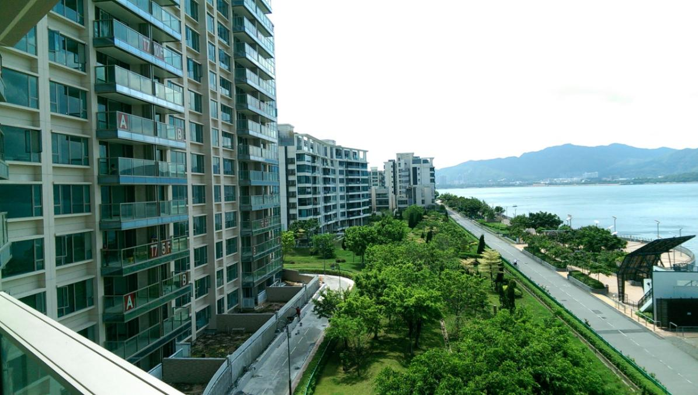

Project Description
The development comprises of 23 residential blocks and 12 villa houses together with clubhouse, carparks, retails and landscape garden with total floor area of 160,000 m² approximately. The project is designed to obtain a platinum grade certification under the Environmental Standard of HK BEAM Plus. Talent carried out M&E design and project administration.

Project Type: | Residential
Project Cost: | HK$600M
Completion: | Jan., 2010 - Jun., 2015
Client: | Top Gallant Ltd. / King Regent Ltd. (Sino Land)

